Assignment - 3

Q Create tables for the following relational model of library management. Apply constraints on the columns and also alter the structure according to your requirements.

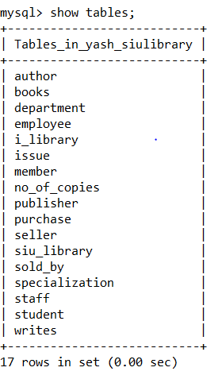

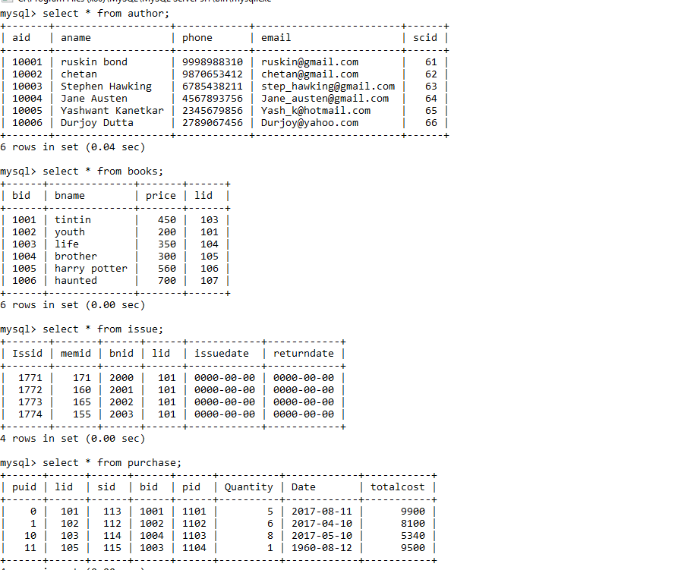
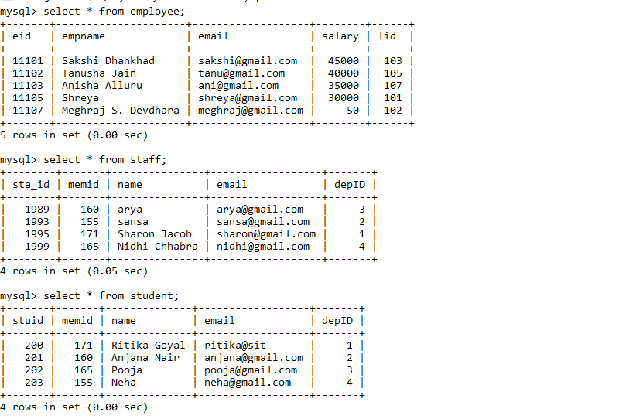
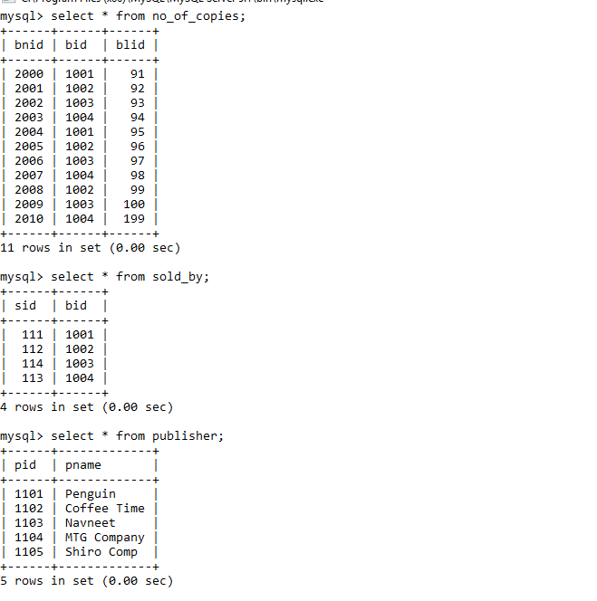
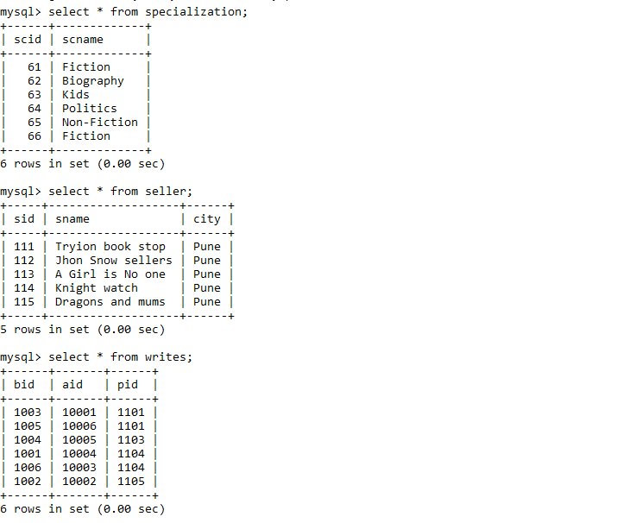
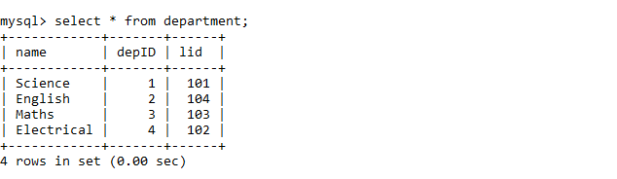
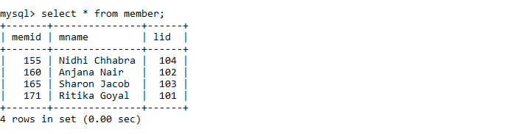
Q Execute following queries on the library database

Which libraries are located in pune city?
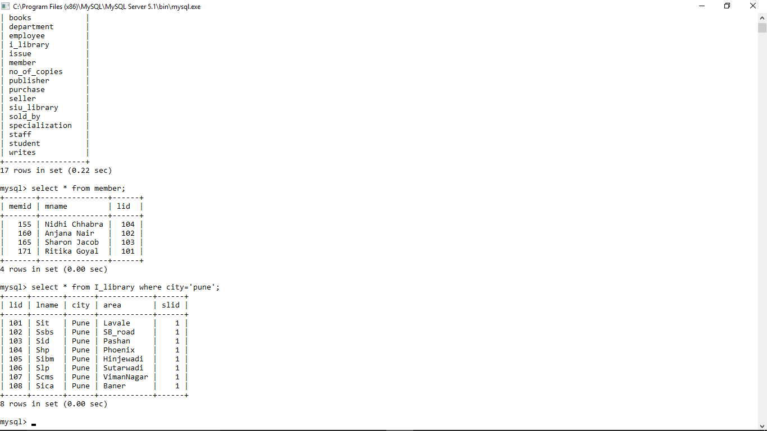
Find the library to which cs department is attached?
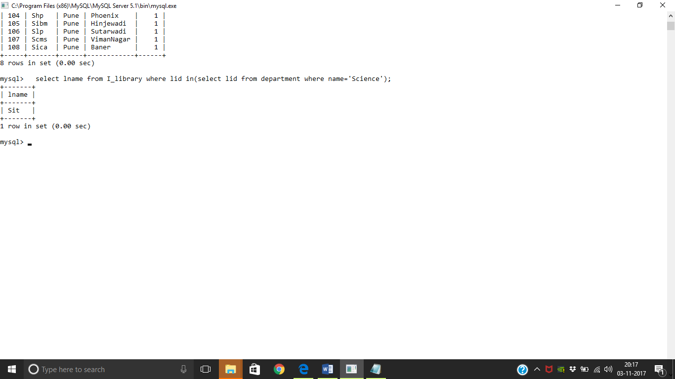
Which students belong to civil department?
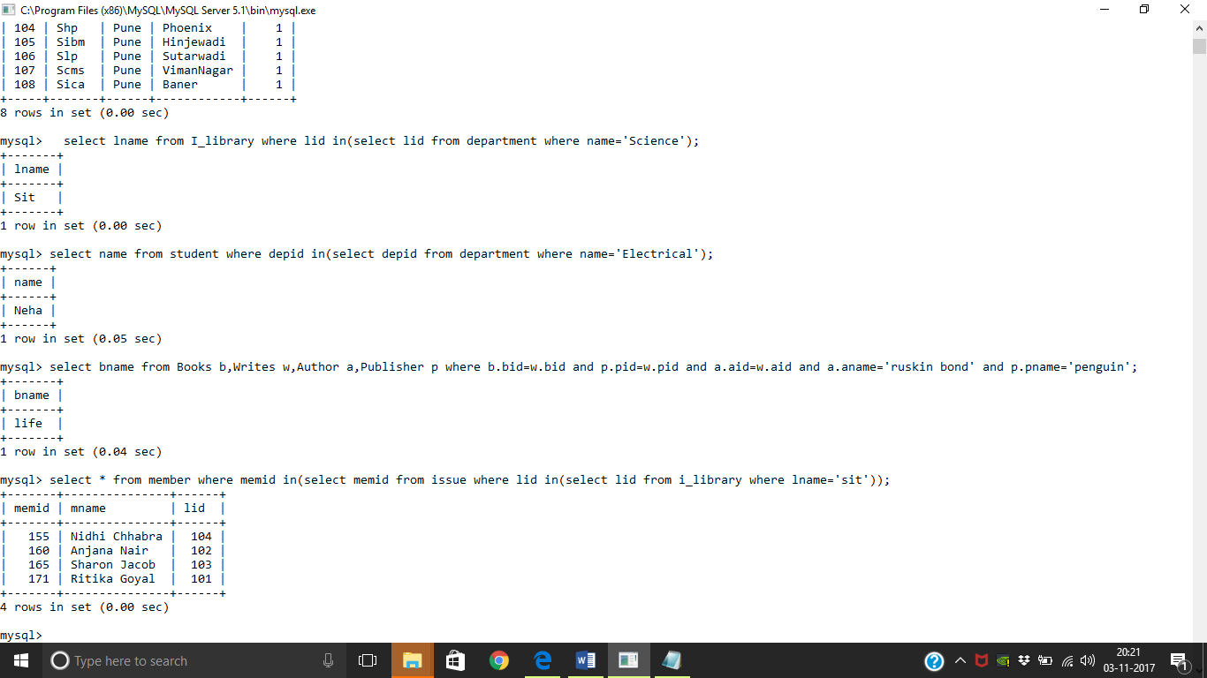

Find out books which are written by “ruskin bond” and published by penguin.

Which members have issued books that belongs to SIT library
How many books have copies less than 5 available in the SIBM library?
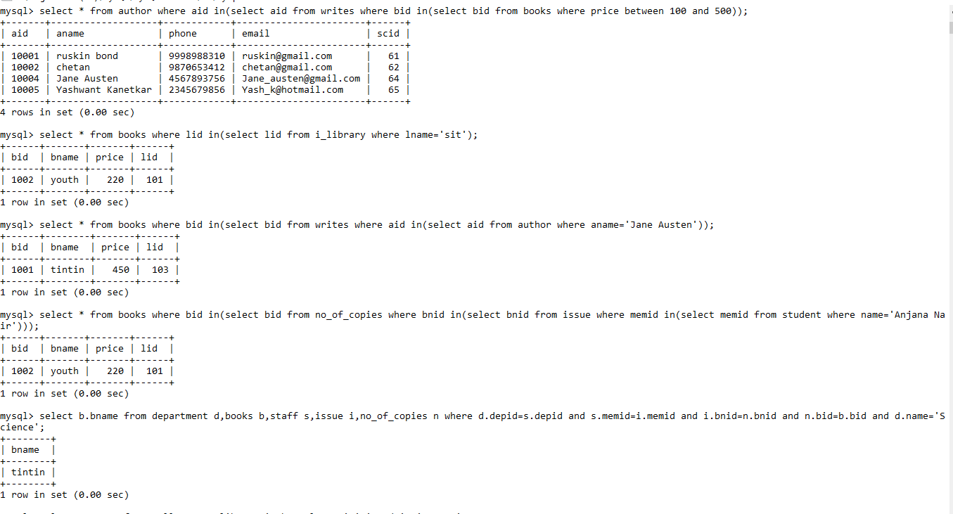
Which staff members starts with letter “A”
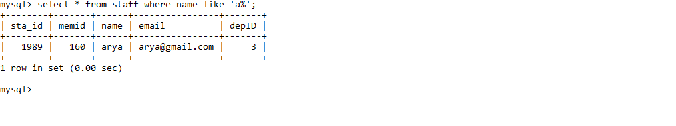
List the books of SIT library

Which books are written by “ jane austen”
Which books are issued by student anjana nair?
Which books are issued by staff of Science department?
Which sellers reside in the same city in which SCHC library resides?
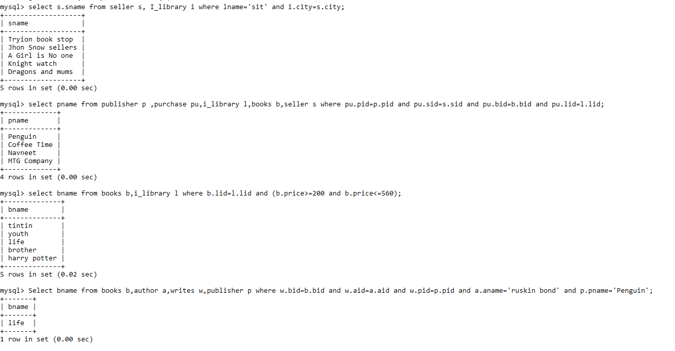

Find out the publishers whose books are provided by the seller “pragati books store” to SSBS library.
Which books does SIT library have in the range of 1000-2500rs range
Which books are published by “ruskin bond” with the publishing house penguin publications?

Assignment – 4
Perform following queries using SQL functions:

Find the cheapest book of SIBM library.
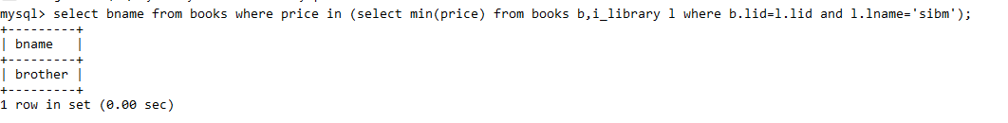
Which library has the costliest book?
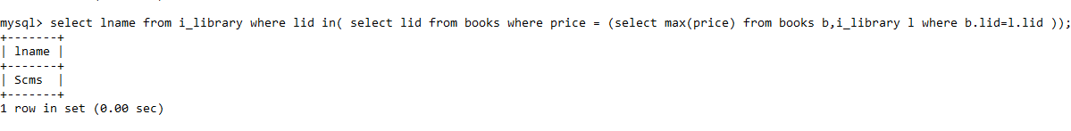
How many students from SIT issued the book?
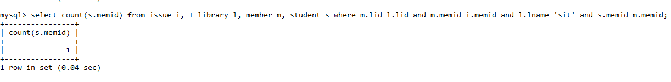
What is the average cost of books in SIT library?
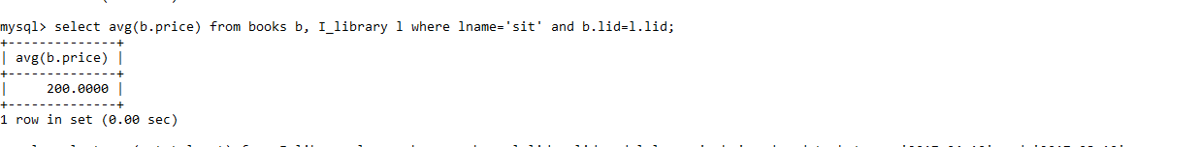

What is the total cost of purchase made by SSBS in the month of January?
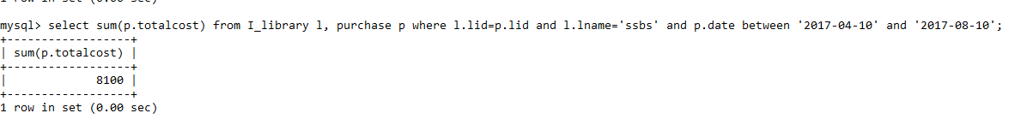
How many books are written by “Shruti”
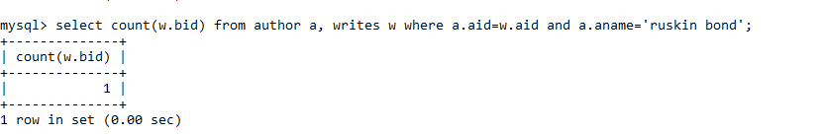
What is the costliest book published by “Pragati Book Store”
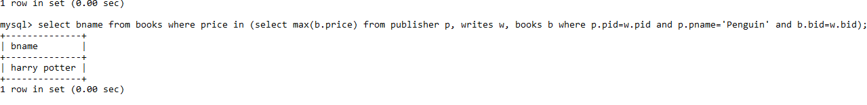
How many total copies of books do SIT has?
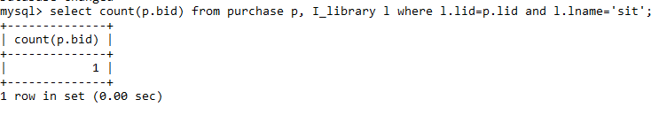

What is the average cost of books written by “Mr. Kumar”?
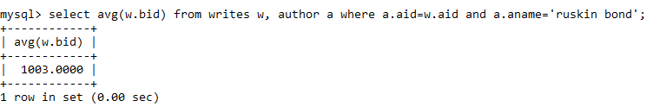
How many books are sold by seller living in Nagpur?
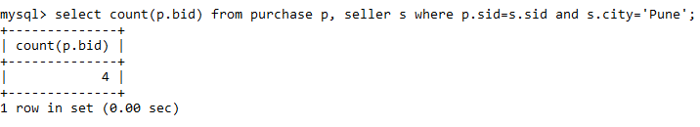
Print the student name in capital who belongs to SSBS
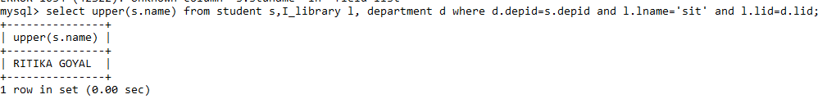
Write a query to display current data and time.
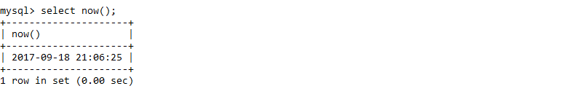

Assignment – 5

Give library wise book details.
select * from Books order by lid;
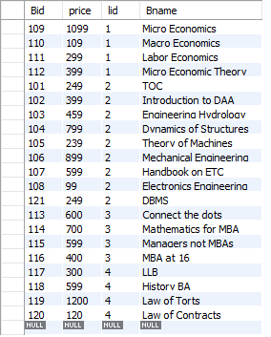

Give citywise seller count
select city, count(Sid) from seller group by city;
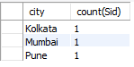
Give departmentwise staff details having average salary greater than 500.
select * from staff where salary > 500000 order by Depid;
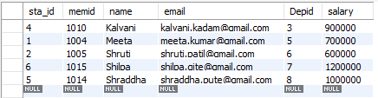

Give bookwise total copies which are available.
select Bid, count(Bl_id) from no_of_copies group by Bid;
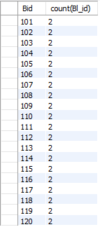
Give authorwise group count who have authored more than 2 books.
select Aid, count(Bid) from writes group by Aid having count(Bid) > 2;
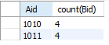
How many books are issued library wise?
select lid, count(BNid) from issue group by lid;
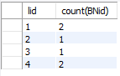
Give librarywise purchase count having totalcost sum > 10000
select lid, count(Prid) from purchase group by lid having sum(totalcost) > 10000;
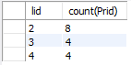

Find first three costliest books.
select * from books order by price desc limit 3;
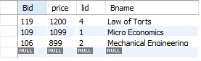
Find the employee of SIT library having least salary
select * from employee e, i_library i where i.lid = e.lid and i.lname = 'SIT' order by salary limit 1;
Find the cheapest books of SLS library
select * from books e, i_library i where i.lid = e.lid and i.lname = 'SLS' order by price limit 1;
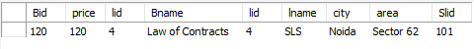
Find out the libraries having maximum books issued.
select lname from i_library where lid in (select i.lid from issue i group by (i.lid) having count(issis) >= all(select count(i1.issis) from issue i1 group by(i1.lid)));
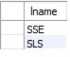
Find out the library having minimum number of total books.
select min(x.count) from (select count(b.bid) as count from i_library i, books b where i.lid = b.lid group by (lname))x;
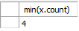

Assignment – 6

Students in the CSIT department.
select s.name from student s inner join department d on s.Depid = d.Depid and d.Dname = 'CSIT';
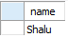
Books in SIT library.
select * from books b inner join i_library i on b.lid = i.lid and i.lname = 'SIT';
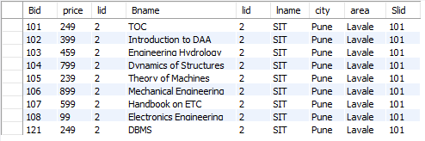
Books with less than 3 copies in SIT library.
create temporary table count_books
(Bid int primary key);
insert into count_books
select p.Bid from purchase p inner join i_library i on p.lid = i.lid and p.quantity < 3 and i.lname = 'SIT';
select * from books b inner join count_books c on b.Bid = c.Bid;
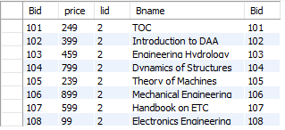
Sellers in the same city as SIT.
select * from seller s inner join i_library i on s.city = i.city and i.lname = 'SIT';

Sellers selling books to SIT.
create temporary table seller_id
(Sid int primary key);
insert into seller_id
select distinct p.Sid from purchase p inner join i_library i on p.lid = i.lid and i.lname = 'SIT';
select * from seller s inner join seller_id i on s.Sid = i.Sid;
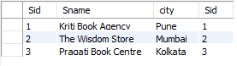
Books authored by Yash, and published by McGraw Hill.
create temporary table book_details
(Bid int primary key);
select distinct w.Bid from writes w, publisher p, author a where w.Aid = a.Aid and w.Pid = p.Pid and p.pname = 'McGraw Hill' and a.Aname = 'Yash';
select * from books b inner join book_details d on b.Bid = d.Bid;
Books authored by 'Yash'.
create temporary table book_details
(Bid int primary key);
insert into book_details
select distinct w.Bid from writes w inner join author a on w.Aid = a.Aid and a.Aname = 'Yash';
select * from books b inner join book_details d on b.Bid = d.Bid;
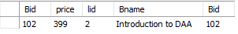

Books issued by Yash.
create temporary table book_details
(Bid int primary key);
insert into book_details
select distinct n.Bid from issue i, no_of_copies n, student s, members m where m.memid = s.memid and s.name = 'Yash' and i.memid = m.memid and n.Bnid = i.BNid;
select * from books b inner join book_details d on b.Bid = d.Bid;
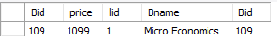

Assignment - 7

Function to multiply two numbers

Delimiter @
Create function multil (n1 int, n2 int)
returns int
Begin
Declare result int;
Set result = n1 * n2;
return result;
End @

select multil (8, 6);

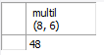

Function to find average of four numbers;

Delimiter @
Create function average(n1 int, n2 int, n3 int, n4 int)
returns float
Begin
Declare result float;
Set result = (n1 + n2 + n3 + n4) / 4;
return result;
End @

select average(1, 2, 3, 4);

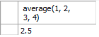

Function to find maximum of two numbers
Delimiter @
Create function maximum(x int, y int)
returns int
Begin
Declare z int;
if x > y then
set z = x;
else
set z = y;
end if;
return z;
end @

select maximum(5, 4);

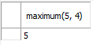

Function to find the library name which has the cheapest books

Delimiter @
Create function cheapbook()
returns varchar(20)
Begin
Declare namelib varchar(20);
Declare minprice int;
select min(price) into minprice from books;
select l.lname into namelib from i_library l, books b where l.lid = b.lid and b.price = minprice;
return namelib;
end @

select cheapbook();



Function to find total number of books in siu library

Delimiter @
Create function totalbooks()
returns int
Begin
Declare total int;
select count(*) into total from books;
return total;
end @

select totalbooks();

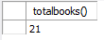

Function to find factorial of a number

Delimiter @
Create function fact(n1 int)
returns int
Begin
Declare result int;
set result = 1;
label: loop
set result = result * n1;
set n1 = n1 - 1;
if n1 > 0 then
iterate label;
end if;
leave label;
end loop label;
return result;
end @

select fact(4);

Function to find total number of books issues by SIT staff

Delimiter @
Create function staffbooks()
returns int
Begin
declare total int;
select count(i.issis) into total from issue i, members m, staff s, i_library l where i.memid = m.memid and m.memid = s.memid and m.lid = l.lid and l.lname = 'SIT';
return total;
end @

select staffbooks();

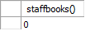

Assignment – 8

Write a procedure to find details of books of a given library.

Delimiter @
create procedure book (in lname text)
begin
select * from books b,i_library l where b.lid=l.lid and l.lname=lname;
end @

call book("SIT");

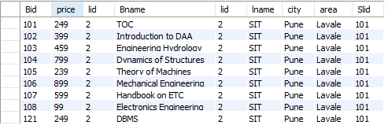

Write a procedure to find out total no. of books written by a particular author.

delimiter @
create procedure tota(in aname text,out tot int)
begin
select count(*) from writes w,author a where a.aid=w.Aid and a.Aname=aname into tot;
end @

call tota('Yash', @tot);
select @tot;

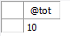

Write a procedure to increase price of books by 10% which are sold by a particular seller to a particular library.

delimiter @
create procedure up(in aname text)
begin
update books set price=price*1.1 where bid in (select w.bid from writes w,author a where w.aid=a.aid and a.aname=aname);
end @

call up("Yash");

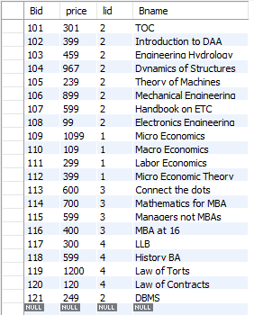

Write a procedure to count total number of publishers who are providing books to a particular library.

delimiter @
create procedure pub(in lname text)
begin
select count(*) from publisher p,i_library l,writes w ,author a,books b where w.pid=p.pid and w.aid=a.aid and b.bid=w.bid and b.lid=l.lid and lname='SIT';
end @

call pub('SIT');

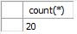

Write a procedure to find the costliest and the cheapest books that a particular library has.
delimiter @
create procedure mm(in lname text)
begin

select b.bname as costliest,max(b.price) ,b1.bname as cheapest,min(b.price) from books b,books b1,i_library l where b.lid=l.lid and b1.lid=l.lid and l.lname='SIT';
end @

call mm('SIT');

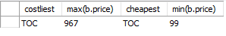
Write a procedure to provide total money spent by a particular library in purchasing books in a particular month.
delimiter @
create procedure cost(in lname text,in mon int)
begin
select sum(p.totalcost) from purchase p ,i_library l where p.lid=l.lid and mon = extract(month from p.date) and l.lname=lname;
end @

call cost('SIBM',07);

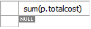
Assignment - 9

create table booksupdate_log(tid int auto_increment, bid int not null, bname varchar(25) not null, action varchar(15), lid int not null, price int not null, changed_on datetime, primary key(tid));
create table purchaseupdate_log(tid int auto_increment, prid int not null, lid int not null, Sid int not null, Bid int not null, quantity int not null, Date varchar(20), action varchar(15), totalcost int, changed_on datetime, primary key(tid));

#Update trigger
Delimiter @
create trigger update_books
after update on books
for each row
begin
insert into booksupdate_log
set action = 'update', bid = old.bid, bname = old.bname, lid = old.lid, price = old.price, changed_on = now();
end @

update books set bname = 'TOC' where bid = 101;
#Insert trigger
Delimiter @
create trigger insert_books
before insert on books
for each row
begin
insert into booksupdate_log
set action = 'insert', bid = new.bid, bname = new.bname, lid = new.lid, price = new.price, changed_on = now();
end @
insert into books values(121, 249, 2, 'DBMS');
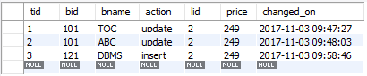

#Update trigger
Delimiter @
create trigger update_purchase_table
after update on purchase
for each row
begin
insert into purchaseupdate_log
set action = 'update', prid = old.prid, lid = old.lid, Sid = old.Sid, Bid = old.Bid, quantity = old.quantity, Date = old.Date, totalcost = old.totalcost, changed_on = now();
end @

update purchase set Date = '11/07/1997' where Prid = 100;

Assignment - 10

Write a view to select all books of SIT library whose cost is less than 500/-
create view book_output as select * from books where lid = 2 and price < 500;
select * from book_output;
